User's manual

Interactive teaching touch all-in-one machine
universal version

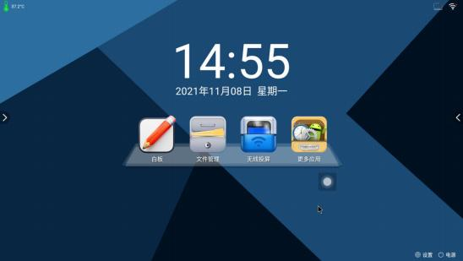

Please read this instruction before use and keep it properly.

catalogue
- Product Introduction....................................................................3
- Product panel socket terminal diagram.....................................6-7
- Step of the first use of the product................................................8
- Computer teaching instructions....................................................9
- Whiteboard,teaching,software,window,interface....................9-10
- Description,of,the,buoyant,toolbar........................................ 11-12
- TV instructions............................................................................13
- Channel selection.........................................................................13
1.1.Remote/control/channel/selection/operation/instructions.........13
1.2.Button/channel/selection/operation..........................................14
2.Image/brightness/audio/debugging/operation/instructions........15-16
7.Wall hanging installation..............................................................17
1.Detailed/description/of/wall/hanging/list.....................................17
2.Wall/mounting/instructions.........................................................18-21
8. Maintenance...............................................................................22
9. Safety tips...................................................................................23-24
10. Product quality assurance card..............................................................25-26

Product introduction

Dear users, thank you for choosing our products. In order for you to use and maintain the machine correctly, please read this instruction carefully before using it, which will help your machine maintain a longer life

Our company's independently developed touch all-in-one machine is the most convenient, simple, and practical human-computer interaction device. It integrates touch technology, computer technology, multimedia technology, audio technology, network technology, industrial manufacturing art, mechanical manufacturing technology, and streamlined integrated design, offering an excellent touch query experience. It efficiently completes information queries and displays, truly achieving a simple and practical human-computer interaction function.

Currently, our company's touch all-in-one machines have been widely adopted in various settings, including schools, training classes, corporate meeting rooms, exhibition halls, brand specialty stores, hotel lobbies, expos, corporate showrooms, shopping malls and supermarkets, banks, and government offices. We have dedicated ourselves to the research and development of touch products for many years, ensuring that our products are highly competitive both technologically and in practical applications.

Product panel port diagram

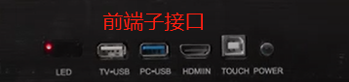

- ② ③ ④ ⑤ ⑥
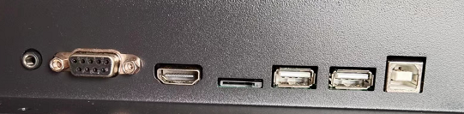
Android rear port

⑦ ⑧ ⑨ ⑩ ⑪ ⑫

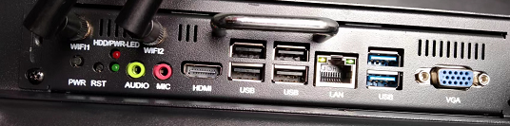
Posterior interface of computer system

⑬ ⑭ ⑮⑯ ⑰ ⑱ ⑲ ⑳ ㉑

- Power indicator light ② USB port for Android system ③ USB port for WINDOWS system
④ HDMI input in advance ⑤ Infrared touch external interface ⑥ Power switch
⑦ Android system sound output port ⑧ rear computer signal input port ⑨ rear HD signal input port
⑩ Android system TF card port ⑪ Android system rear USB port ⑫ infrared touch external port
⑬ Built-in computer system start button (non-daily operation) ⑭ Built-in computer system restart button (non-daily operation)
⑮ Built-in computer system sound output port ⑯ built-in computer sound input port ⑰ built-in computer HD output interface
⑱⑳ Built-in computer USB port ⑲ Wired network port ㉑VGA signal output port

First use steps of the product

Step 1: Plug the power cord into the AC-220V socket and turn on the AC-220V ON/OFF [The red light of the switch indicates that it is on, and the light does not indicate that it is off]
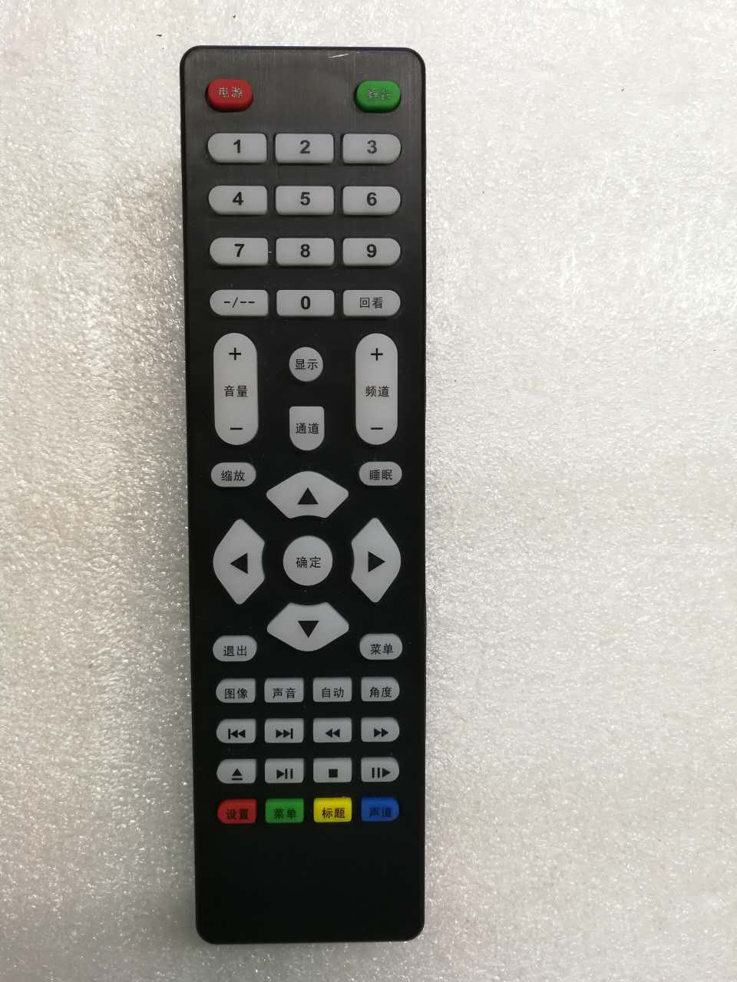
Open/closed power button
Step 2: Press the power button on the keypad or the red power button on the remote control. [The screen will appear at this time
Blue interface and display HMDI1]
Step 3: Turn on the computer according to the computer key [as shown in the diagram of the computer terminal]. At this time, the HDMI1 channel interface will display the host startup interface. Wait for about 1 minute after the interface is over
TV commentary
1. Channel selection
Mute button
Open/closed power button
1.1 Operation instructions for channel selection of remote control
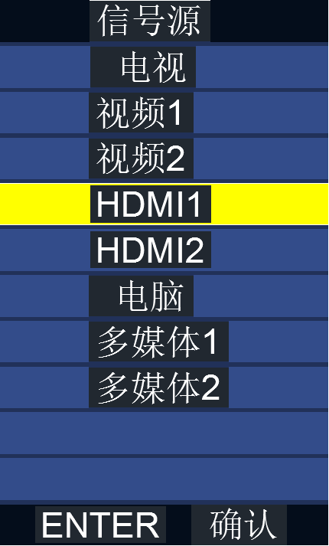
Channel keys
● Press the channel key to display the channel list:
● Select by ▲/▼ key: Press the OK key or the key to enter. [Factory HDMI1 default]
basic operation
● Press the menu button to open the main menu
● Press the / key in the main menu to select the option you want to adjust.

● Press or confirm the key to enter its submenu.
● Press the menu key to save and return to the previous level of the menu or press the confirm key to exit the menu
● Press the ▲/▼ key to select the option you want to adjust and press the / key to enter the submenu for adjustment.

1.2 Button Channel selection operation instructions

Figure I
● Press the power button to open the TV interface
● Click the signal source key, and the signal source column is displayed in the upper right corner of the screen.
● Press the signal source key or channel +/-key again to select the required corresponding signal channel [factory default HDMI1]
● After selecting the corresponding signal channel, press the "Volume +" button to confirm.

Interface shortcut keys:
: Click to open and write the meeting
: Click to perform the mobile phone screen operation
: Click to open the default Android internal file management, after entering, you can select the external memory Settings


: Click to enter the Android application interface and menu Settings

: Click to open the Settings menu

: Click to open the shutdown option

Introduction to multi-screen interaction function setting


- After clicking the icon on the main interface, the following interface will pop up (the hotspot function needs to be opened first):
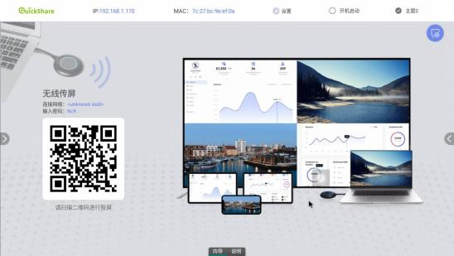
Android phones scan the qr code in the lower left corner to download the screen casting software for screen casting.
- After switching to the instructions, it looks like this:

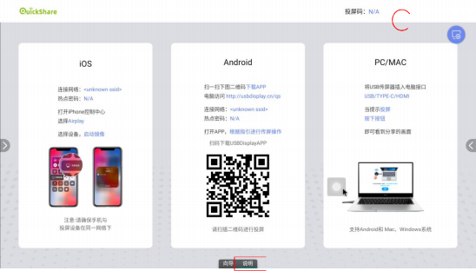
Android phones, iphones and computers can be used to cast the screen according to the steps shown in the interface. Click the setting icon in the upper right corner to set the casting function.
Wireless screen transmission introduction

1. Apple device screen projection:
Connect the Apple device to the conference machine's hotspot AndroidAP-xxxx, and then open the phone AirPlay mirror to transfer the screen.

2. Screen projection on Android devices:
Scan the QR code displayed in the lower left corner of the mobile phone or enter (http://120.26.86.122/res) download the client in the mobile web page, then link the mobile phone to the conference machine hotspot AndroidAP-xxxx, open the client, click the search connection to the corresponding machine in the lower right corner; or scan the code to project the screen.
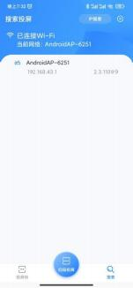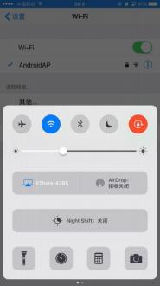

When the phone is connected, on the connection page, you can select from options such as screen casting, virtual mouse remote control, screenshot, mirror image, video, music, images, and documents. By clicking on a document, you can push PPT, Word documents, Excel spreadsheets, or PDFs to the entire device for playback. After pushing a document, the phone will transition to the virtual mouse page: touch the blank area of the virtual mouse to control the large screen, and touch the right and bottom sides to scroll through the documents.
4. Software screen casting for computer equipment:
In the absence of a screen transfer device, the PC mirror screen projection is realized by running green software, and the function effect is similar to that of a screen transfer device. To transfer the screen, connect the laptop to the Internet, open the web browser and enter the address http://www.usbdisplay.cn/, and the download page will pop up as shown in the following figure:

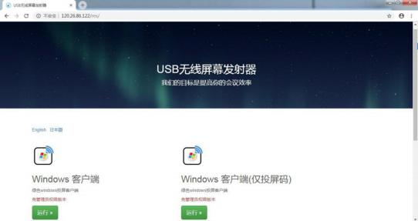

Click to download the Windows client, and then double-click to run as shown:
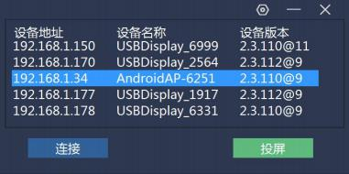

At this point, the list of machines will list the smart meetings that can be found in the current LAN where the laptop is located. Double-click the specified machine or IP address to automatically connect to the device. The usage process after screen transmission is similar to USB screen transmission

Introduction to PC hardware screen transmission (not standard, optional purchase)
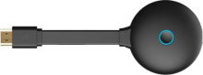

- First, open the wifi hotspot of the Android tablet, and then connect the screen transfer device to the USB port of the Android card for pairing and registration. After successful registration, the following interface will pop up:
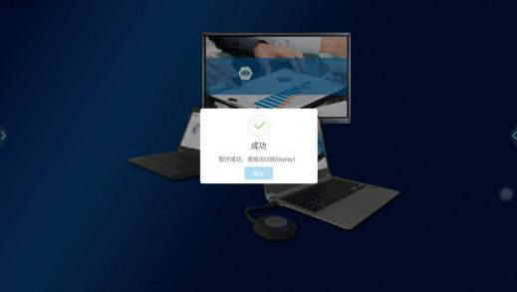
Note: Before matching, open the hotspot and then connect the screen to the projector for pairing.
2. Connect the registered screen transmitter to 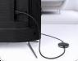the COMPUTER USB port. When the display interface prompts "can be shared", press the screen transmitter to share it in the conference
The corresponding sharing screen is displayed on the board.
- When the screen transmitter is successfully connected to the whole machine, a round green button will appear in the upper left corner, and the number displayed represents the number of screen transmitters connected to the whole machine. Click "Expand" to display the host mode, repeatedly click the device under the screen or click the already connected device to start screen transmission, as shown in the following figure:
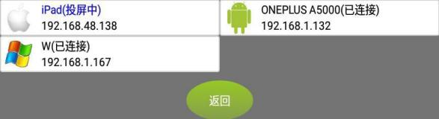
During the screen transmission process, after checking and locking, the computer screen of other users will not be able to seize the screen of the user who is transmitting the screen

5. Precautions for using the screen transmitter:
When the user's computer uses the screen transfer device for the first time, some computers will automatically install the driver, and the screen transfer device will automatically install and run. If the computer cannot automatically install the driver, you can click (Computer) → removable storage device, double-click the disk symbol CD drive (USBDisplay).
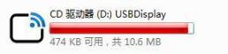
The layout of the disk is as follows:

Note: Windows10 system needs to turn off the firewall before installing the driver.

After the driver installation is complete, a prompt will appear in the lower right corner of the computer: Press to transfer screen.
Precautions: In some computer systems, due to the interception of anti-virus software, even if it is not the first time to use, the screen transfer device may not run by itself. At this time, you need to execute the main program in USBDisplay as follows:

Wall mount installation
1. Detailed description of wall mounting list
name | Physical images and specifications | quantity
Wall strips | 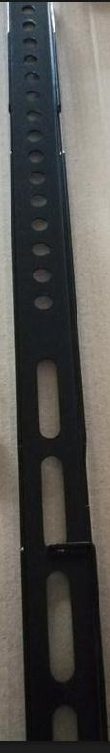 | 2
Wall strip screws [with round washer] | 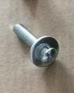 Mechanical tooth 6*25mm | 4
Wall-mounted strip gasket | 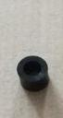 Inner diameter 7mm | 4
Wall-mounted frame | 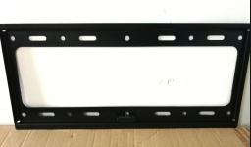 | 1
Plastic expansion tube | T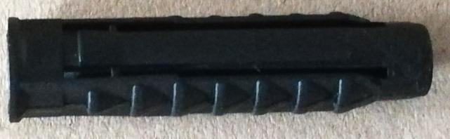he diameter of the wall opening is 9mm | 4
Expansion pipe screw [with round washer] | 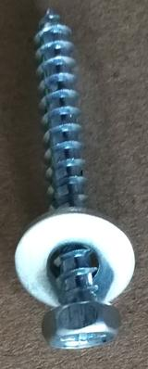 Self-socketed teeth 6*45mm | 4
gradienter | 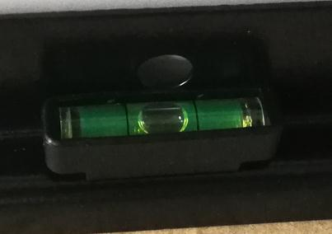 | 1
Anti-slip screws | 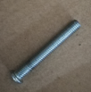 Mechanical tooth 5*35 mm | 2

2 Wall mounting instructions
2.1 Install the wall strip on the screw column of the rear cover of the whole machine
2.1.1 Place the machine flat on a soft table, as shown in Figure 1
Figure I
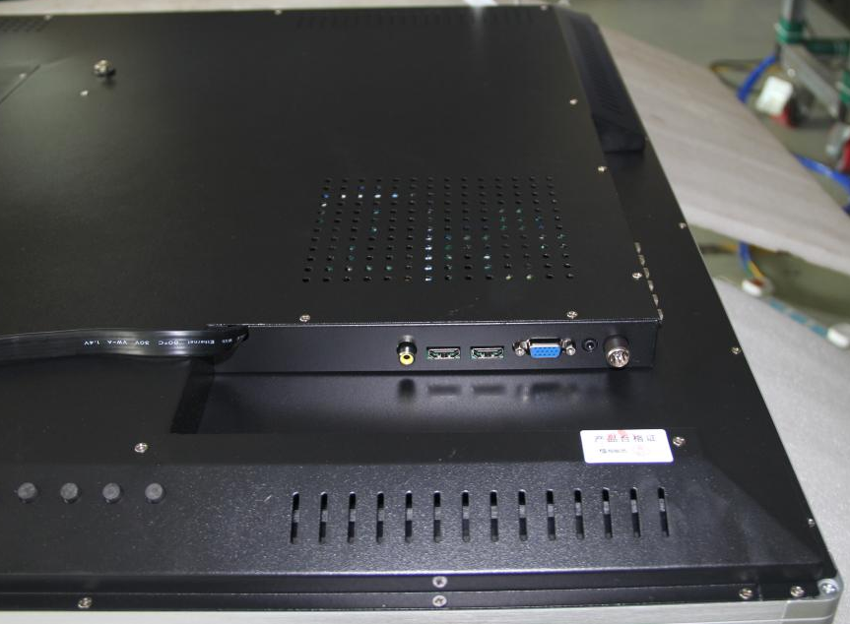
2.1.2 Use a cross screwdriver to twist out the screw at the red circle position in Figure 2. [The screw should be placed at least 20cm away from the edge of the machine to prevent the whole aluminum frame from being scratched] as shown in Figure 2
Note: The screws marked in red circle on the rear cover of the whole machine are the screws for the K-type horizontal base
Figure II
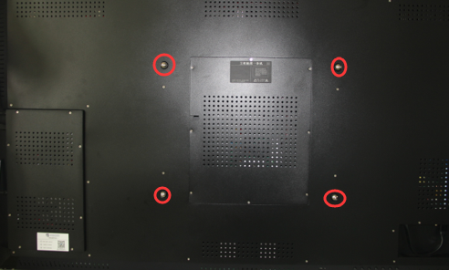
2.1.3 Refer to the wall mounting list to obtain the following materials;
name | Physical images and specifications | quantity
Wall strips |  | 2
Wall strip screws [with round washer] | Mechanical tooth 6*25mm | 4
Wall-mounted strip gasket | Inner diameter 7mm | 4
2.1.4 Place the wall mounting washer on the wall mounting post on the rear cover of the machine [as shown in Figure 1]. Pass the wall mounting screw through the 5th hole on the wall mounting strip [as shown in Figure 2]. Use a Phillips screwdriver to partially screw in the wall mounting screw from the hole [to help position it], then pass and tighten the next wall mounting screw [as shown in Figure 2]. Repeat this process to install another wall mounting strip [as shown in Figure 3].
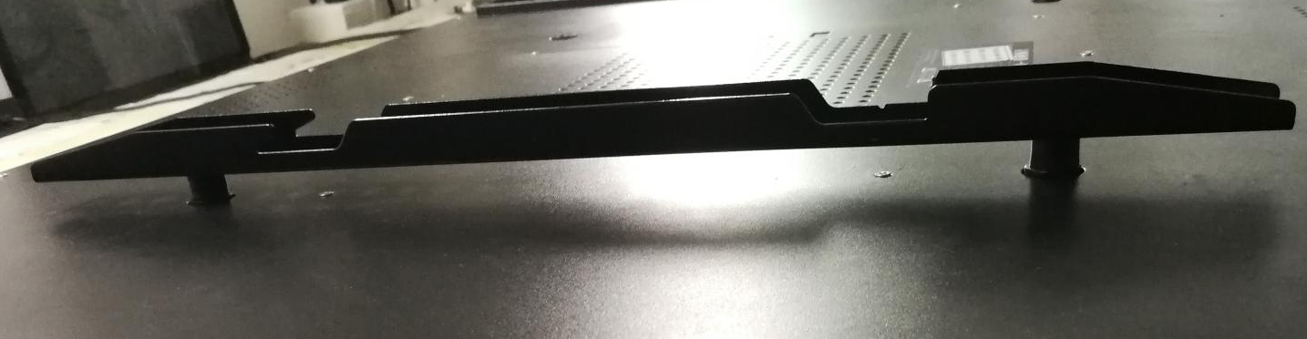Figure I 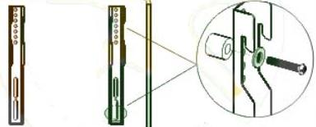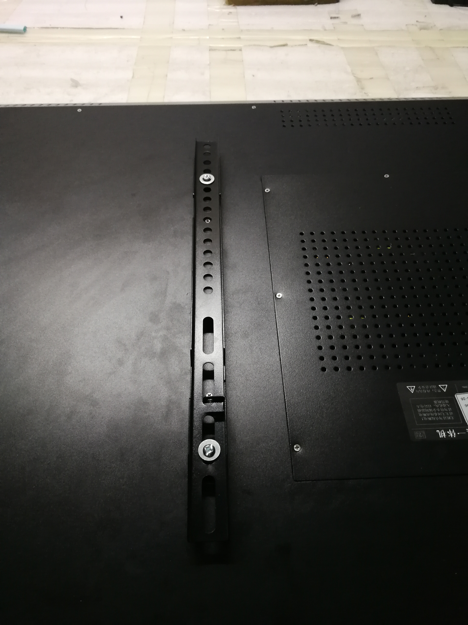
auxiliary word for ordinal numbers
5
A round hole
Wall-mounted strip gasket
Figure II Figure III Figure II Figure III
2.2 Install the wall frame on the wall
2.2.1 Take the following materials according to the wall hanging installation list;
name | Physical images and specifications | quantity
Wall-mounted frame |  | 1
Plastic expansion tube | The diameter of the wall opening is 9mm | 4
Expansion pipe screw [with round washer] | Self-socketed teeth 6*45mm | 4
gradienter |  | 1
2.2.2 Place the wall frame flat on the wall with a level, and mark the position 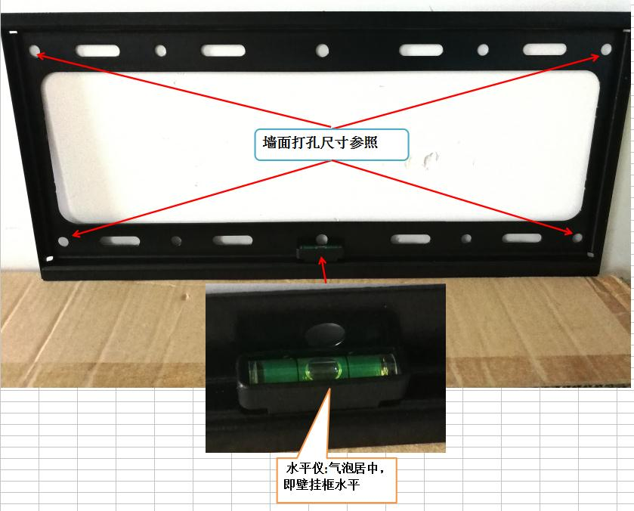of the hole size, as shown in the following figure
2.2.3 A round hole with a diameter of 9mm shall be drilled at the wall marking position;
Knock the plastic expansion tube into the hole [knock the expansion tube parallel to the wall];
Use the expansion pipe screw 6*45 to fix the wall frame on the wall, as shown in the figure below
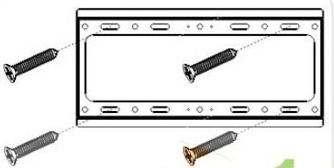
2.2.4 Clip the machine with the wall strip on the wall bracket and fix it with anti-slip screws, as shown in the figure below
Anti-slip screws | Mechanical tooth 5*35 mm | 2
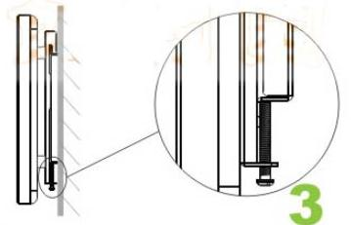
Anti-slip screws
The product completes the entire installation

tending
Use tips
1. Before shutting down, please turn off the system and then turn off the main switch. Abnormal shutdown frequently occurs
Causes system and hardware damage
- The touch screen is a glass product, which is fragile. Please be careful when moving it;
- Do not plug or unplug any live parts of the equipment, including external equipment, while it is energized;
- When the equipment is not in use, disconnect the power supply and cover it with a dust cover;
- Please do not pull the connection cable inside the machine, otherwise it will cause power or signal
Open circuit, short circuit;
6. When a fault occurs, immediately cut off the main power supply, unplug the power plug, and stop using it
Use it and contact the dealer in time
- Do not open for repair without permission.

Maintenance points
1. Before turning on the machine every day, use a soft cloth (or dipped in clean water) to remove dust and fingers from the surface of the touch screen
Wipe the skin clean;
2. When cleaning the body, use a soft dry cloth to wipe it, do not use wet or with
Do not let water drop into the equipment when wiping with chemical cloth.

Safety tips

source
Please check and ensure that the voltage value on the rear shell nameplate of the whole machine matches the main supply voltage value;
Make sure the product is installed or placed out of reach of children
Please unplug the power cord during thunderstorms or lightning
Please unplug the power plug when no one is in the room or when it is not used for a long time
Avoid physical or mechanical damage to the power cord;
Use a dedicated power cord or adapter. Do not modify or extend the power cord

screen
When writing on the screen, please do not use hard or sharp objects instead of fingers or pens;
When cleaning, please turn off the machine and unplug the power plug;
Please wipe the screen with a soft, dust-free cloth;
Do not spray water or cleaner directly on the screen
Do not display a high brightness picture on the screen for a long time.

lay up
Do not place the equipment in an unstable, easy to fall place;
Do not put the equipment in the sun, wind and sand, heavy oil fume, electric heating, boiler and other high temperature heat source or strong light source;
Do not put the equipment in places where strong electricity, strong magnetic field, strong radiation and other direct action on the equipment;
Do not use the equipment in a humid environment, low liquid splash, strong corrosive gas, flammable gas leakage and other harsh environment;
Do not insert any items into the interior of the device;
Do not place heavy objects on the equipment to avoid excessive pressure, causing the equipment to fail to operate.

temperature
Please do not place the equipment near the electric radiator;
When the equipment is transferred from the low temperature area to the high temperature area, please place it for a period of time before turning on the power to fully dissipate the internal condensation;
The operating temperature of the equipment in normal environment is 0℃-38℃.

humidity
Do not expose the equipment to rain, moisture or water;
Please keep the room dry, ventilated and the normal working humidity of the equipment is 10-90%.

ventilate
Please put the equipment in a ventilated place to ensure good heat dissipation;
Ensure that the equipment is at least 10 cm on the left or right or behind, and at least 20 cm at the bottom and top for heat dissipation.

Product quality assurance card
Dear users:
First of all, thank you for choosing Dezheng series products. In order to make our service more satisfactory for you, please read this manual carefully and keep this quality assurance card properly after purchase
Mandate for maintenance
- The warranty period of the whole machine is one year, and the warranty period of the accessories is three months.
- During the warranty period, the faults caused by normal use in accordance with the instructions (judged by our official staff) will be repaired free of charge.
- During the warranty period, if any of the following occurs, it must be repaired at a charge:
- Unable to provide this guarantee card and valid purchase voucher.
2) Faults and damages caused by misuse and improper repair.
3) Faults or damages caused by transportation, moving and falling after purchase.
4) Other inevitable external factors cause failure and damage.
5) Damage caused by water or other solutions in the equipment due to improper use.
6) Damage caused by using a power supply other than the specified voltage.
4. The appearance of the product, consumable parts and accessories are not covered by the warranty: Consumable parts and accessories include (touch pen, national standard power cord, remote control battery, instruction manual [including product quality guarantee card], actual accessory package is subject to)

